

Project Name: TrekHub

Branch PG-DAC March-2023

Documentation On

**“TrekHub”**

PG-DAC March-2023

**Guided By: Snehal Somvanshi**

Submitted By :

**Group No: 14**

* **Tushar Gahiwal 230343020028**
* **Rushikesh Sapkal 230343020082**
* **Kedar Jagtap 230343020039**
* **Mayur Torawane 230343020104**

**Table of Contents**

**1. Introduction 4**

1.1 Document Purpose **4**

1.2 Project Background **4**

1.3 Aim & Objectives **4**

**2. Business Requirements Overview**…………………………………………………………**5**

**3.Functional Requirements** **6**

3.1 Trekker Module **6**

3.2 Guide Module **6**

3.3 Admin Module **6**

**4.** **Non-Functional Requirement………………………………………………………………7**

**5. Use Case Diagram 8**

5.1 Admin **9**

5.2 Guide **10**

5.3 Trekker **11**

**6. Database Design 12**

1Role **12**

2 User **12**

3 Login…………………………………………………………………………………… **13**

4 Treks **13**

5 Plantreks **13**

6 Trekimages **13**

7 Trekbooking **13**

8 Payment **13**

**7. E-R Diagram………………………………………………………………………………………14**

**8. Snapshots 15**

**9. Conclusion 20**

**List of Figures**

**Use Case Diagrams 17**

Fig 1 Admin 8

Fig 2 Guide 9

Fig 3 Trekker 10

Fig 4 ER Diagram 14

1. **Introduction:**
   1. **Document Purpose:**

This document communicates the business requirements and scope for developing TrekHub System. The scope of this document is to define the functional and non-functional requirements, business rules and other constraints requirements.

## Project Background:

Currently, there is no computerized system available under a single umbrella that provides services for trekking bookings. In current situation peoples are searching for centralize platform to solve their trekking related issues like lack of information about trekking destination, best routes to reach, transportation, food, stay, local guidance, language barrier, health and safety problems. There are no facilities is present to tackle all these problems in one place.

## Aim & Objectives:

The main objective of this project is to design a website that will help trekkers from all over India plan their trekking events and provide services suitable for individuals seeking for adventures, thrilling, and memorable experiences. This website will help trekkers to find suitable trekking events with appropriate packages so that trekkers can easily plan a trip with a trekking guide.

1. **Business Requirements Overview:**

# The administrator has the right to approve and modify the packages.

# The administrator can manage guide information.

# Admin can plan new packages.

# Trekkers can search for packages by selecting dates and locations.

# Trekkers can book their events.

# Functional Requirements Overview:

TrekHub System consists of three modules described as below.

1. Admin Module
2. Guide Module
3. Trekkers Module

# 3.1 Admin Module

* TrekHub System should provide all authority to admin how to handle the system.
* The administrator can manage guide and trekkers authorization.
* Admin can create packages as well as modify the packages.
* Admin can track records of completed as well as scheduled events.
* Admin can track revenue details.
* Admin can plan events.
* Admin can see transaction details.

# 3.2 Guide Module

* Guide can see scheduled events.
* Guide can login to his account.
* Guide can see his assign events in his login.
* Guide can see information related to events.

# 3.3 Trekkers Module

* Trekker can see all schedule events.
* Trekker can able to filter the event according to requirement.
* Trekker can register and login to his own account.
* Trekker can book events after login .
* Trekker can pay online.
* Trekker can give Feedback.

1. **Non-Functional Requirement:**

* The website should use professional design, look and feel and color scheme.
* Users will have no limitations for accessing the application through Internet. The portal being an internet application, it is difficult specify exact number of visitor or users. Hence we will target the system to support between 5 and 10 million users on launch of phase 1.
* Being a public website, the site must follow general usability guidelines for menus, navigation, colors, links and other actions provided on the screens.
* The system should be designed in such a manner that user will be able to complete tasks in minimum number of steps.

## 5. Use-Case Diagram

**5.1 Admin:**

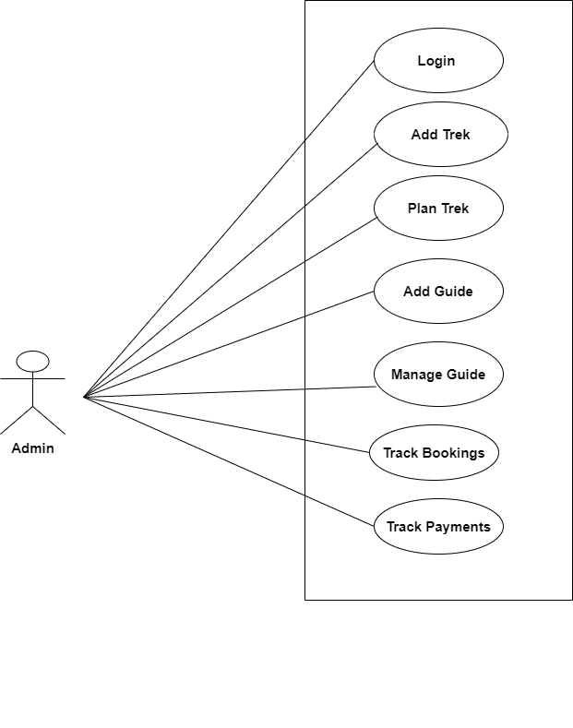

Fig. Use-Case Diagram for Admin

## 5.2 Trekker:

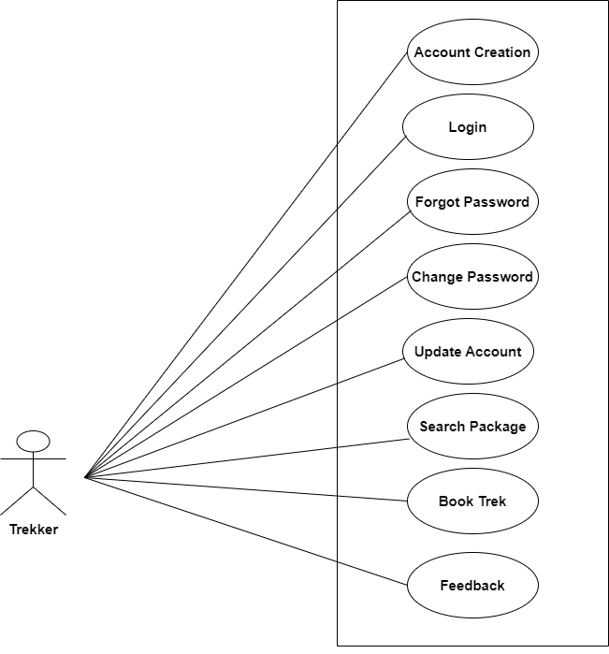

Fig. Use-Case Diagram for Trekker

**5.3 Guide:**  
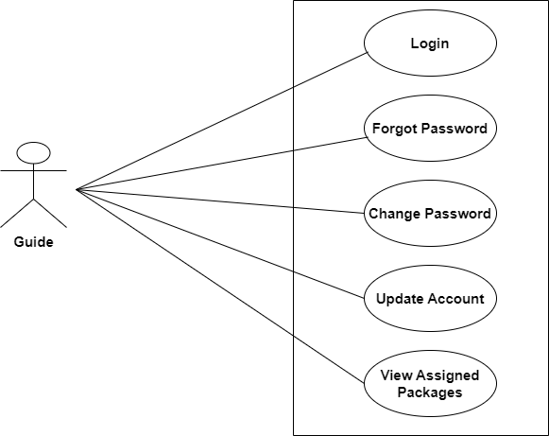

Fig. Use-Case Diagram for Guide

1. **Database Design:**

**1] roles table**

|  |  |  |  |  |  |
| --- | --- | --- | --- | --- | --- |
| roles | | | | | |
| Field | Type | Null | Key | Default | Extra |
|  |
| role_id | int | No | PRI | NULL |  |  |
| role_name | varchar(15) | Yes |  | NULL |  |  |

**2] users table**

|  |  |  |  |  |  |
| --- | --- | --- | --- | --- | --- |
| users | | | | | |
| Field | Type | Null | Key | Default | Extra |
|  |
| user_id | int | NO | PRI | NULL | auto_increament |  |
| fname | varchar(20) | NO |  | NULL |  |  |
| lname | varchar(20) | NO |  | NULL |  |  |
| email | varchar(45) | NO |  | NULL |  |  |
| contact | varchar(15) | NO |  | NULL |  |  |
| adharno | varchar(45) | YES |  | NULL |  |  |
| gender | varchar(10) | YES |  | NULL |  |  |
| addressline | varchar(200) | YES |  | NULL |  |  |
| pincode | int | YES |  | NULL |  |  |
| user_login_id | int | YES | MUL | NULL |  |  |

**3] login table**

|  |  |  |  |  |  |
| --- | --- | --- | --- | --- | --- |
| login | | | | | |
| Field | Type | Null | Key | Default | Extra |
|  |
| login_id | int | NO | PRI | NULL | auto_increament |  |
| uid | varchar(45) | NO |  | NULL |  |  |
| pwd | varchar(45) | NO |  | NULL |  |  |
| role_id | int | YES | MUL | NULL |  |  |

**4] treks table**

|  |  |  |  |  |  |
| --- | --- | --- | --- | --- | --- |
| treks | | | | | |
| Field | Type | Null | Key | Default | Extra |
|  |
| trek_id | int |  | PRI |  | auto_increament |  |
| trek_name | varchar(45) |  |  |  |  |  |
| duration | varchar(45) |  |  |  |  |  |
| capacity | int |  |  |  |  |  |
| description | longtext |  |  |  |  |  |
| location | varchar(45) |  |  |  |  |  |
| level | varchar(45) |  |  |  |  |  |

**5] plantreks table**

|  |  |  |  |  |  |
| --- | --- | --- | --- | --- | --- |
| plantreks | | | | | |
| Field | Type | Null | Key | Default | Extra |
|  |
| plantreks_id | int | NO | PRI | NULL | auto_increament |  |
| start_date | date | NO |  | NULL |  |  |
| price | decimal(9,2) | NO |  | NULL |  |  |
| Avail seats | int | NO |  | NULL |  |  |
| last_date_apply | date | NO |  | NULL |  |  |
| trek_id | int | NO | MUL | NULL |  |  |
| guide_id | int | NO | MUL | NULL |  |  |
| status | varchar(45) | NO |  | NULL |  |  |

**6] trekimages table**

|  |  |  |  |  |  |
| --- | --- | --- | --- | --- | --- |
| trekimages | | | | | |
| Field | Type | Null | Key | Default | Extra |
|  |
| trek_image_id | int | NO | PRI | NULL | auto_increament |  |
| trek_image | longblob | YES |  | NULL |  |  |
| plantreks_id | int | YES | MUL | NULL |  |  |
| trek_id | int | YES | MUL | NULL |  |  |

**7] trekbooking table**

|  |  |  |  |  |  |
| --- | --- | --- | --- | --- | --- |
| trekbooking | | | | | |
| Field | Type | Null | Key | Default | Extra |
|  |
| booking_id | int | NO | PRI | NULL | auto_increament |  |
| booking_date | date | YES |  | NULL |  |  |
| trekker_id | int | YES | MUL | NULL |  |  |
| plantrek_id | int | YES | MUL | NULL |  |  |
| members | int | YES |  | NULL |  |  |
| amount | decimal(9,2) | YES |  | NULL |  |  |

**8] payment table**

|  |  |  |  |  |  |
| --- | --- | --- | --- | --- | --- |
| payment | | | | | |
| Field | Type | Null | Key | Default | Extra |
|  |
| payment_id | int | NO | PRI | NULL | auto_increament |  |
| payment_mode | varchar(45) | YES |  | NULL |  |  |
| transaction_id | varchar(45) | YES |  | NULL |  |  |
| amount | varchar(45) | YES |  | NULL |  |  |
| payment_date | date | YES |  | NULL |  |  |
| booking_id | int | YES | MUL | NULL |  |  |
| plantrek_id | int | YES | MUL | NULL |  |  |
| trekker_id | int | YES | MUL | NULL |  |  |

**9] feedback table**

|  |  |  |  |  |  |
| --- | --- | --- | --- | --- | --- |
| feedback | | | | | |
| Field | Type | Null | Key | Default | Extra |
|  |
| feedback_id | int | NO | PRI | NULL | auto_increament |  |
| rating | int | YES |  | NULL |  |  |
| comment | varchar(500) | YES |  | NULL |  |  |
| trekker_id | int | YES | MUL | NULL |  |  |
| plantrek_id | int | YES | MUL | NULL |  |  |

## ER-Diagram:

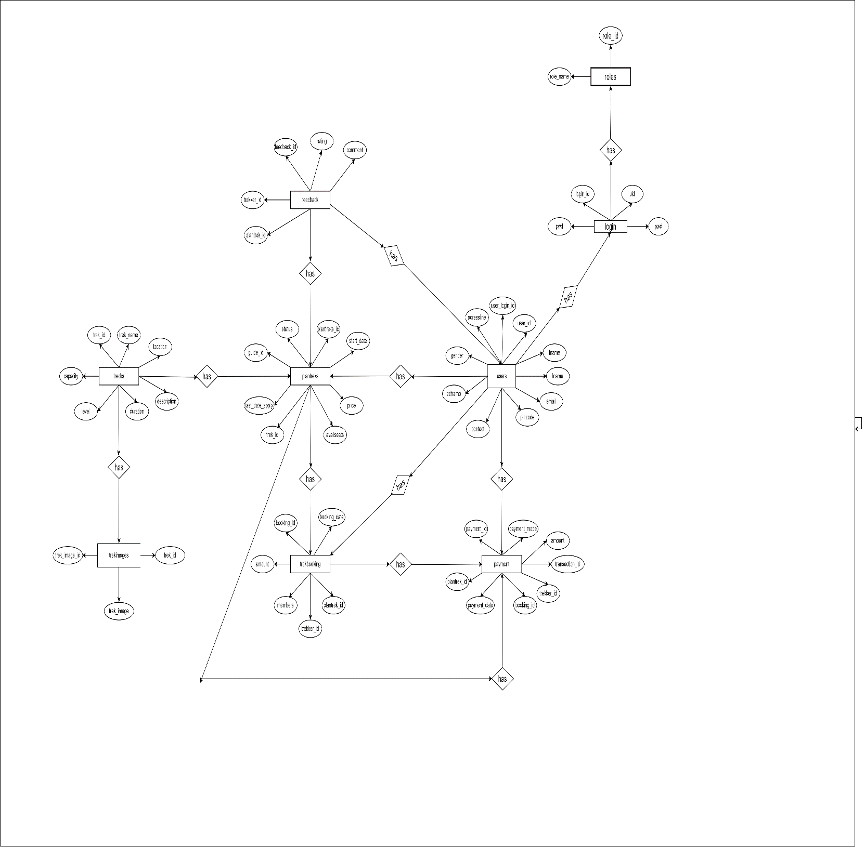

**E-R diagram shows database of TrekHub**

**8. Snapshots:**

**8.1 Home Page:**

Following snapshot shows the Home page for TrekHub before Login.

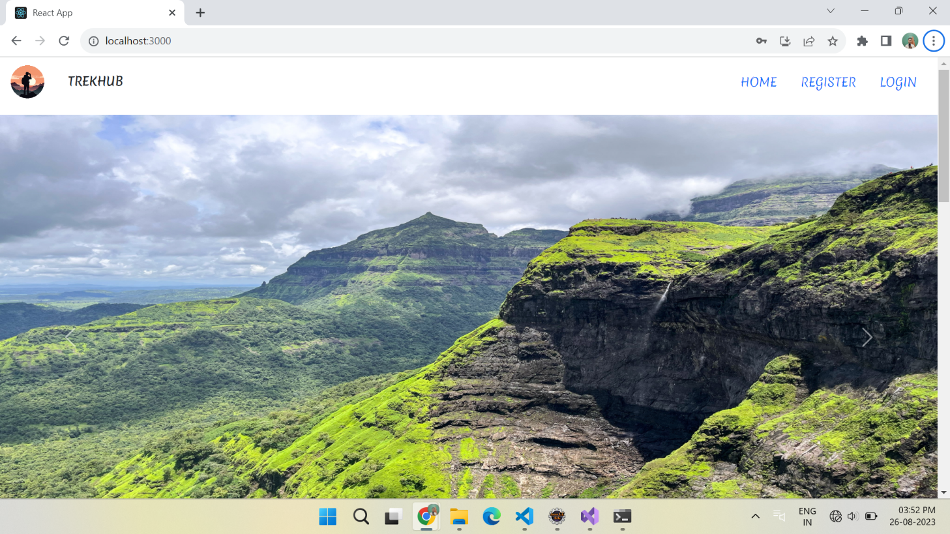

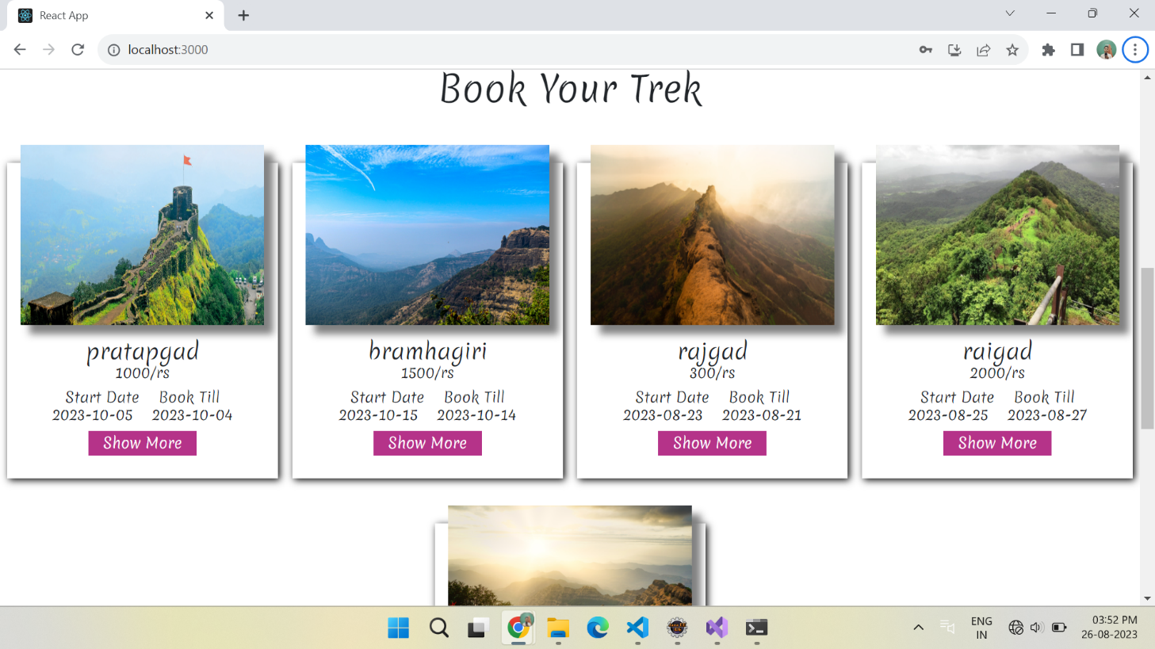

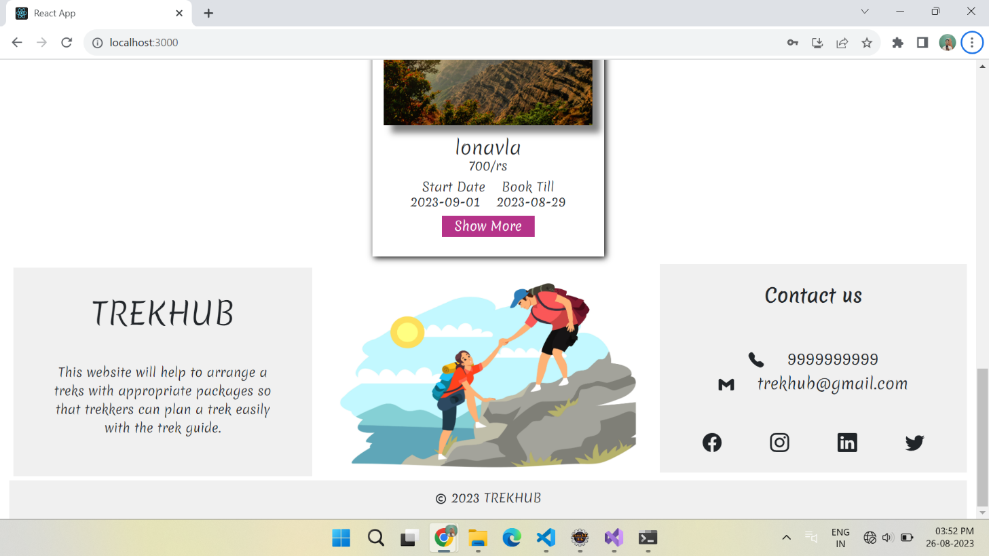

This page contains following controls

* Home
* Registration
* Login Button

This page also contains footer consisting information about the website and contact us details.

**8.2 Login Page**

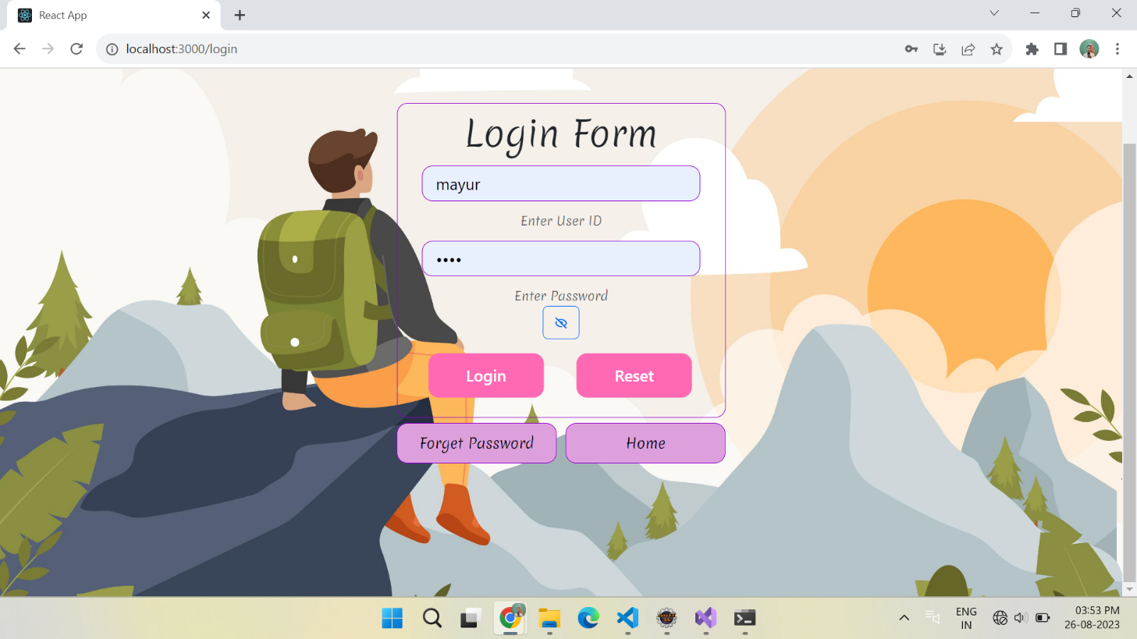

**8.4 Admin Home Page**

**8.4.1 Admin Home Page**

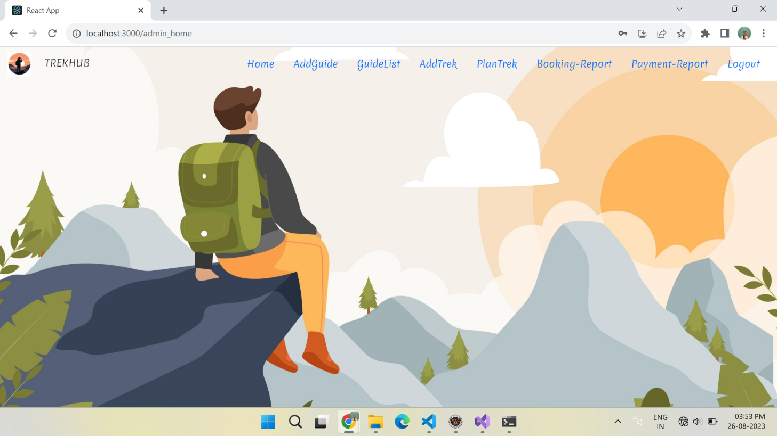

**8.4.2 Add Guide**

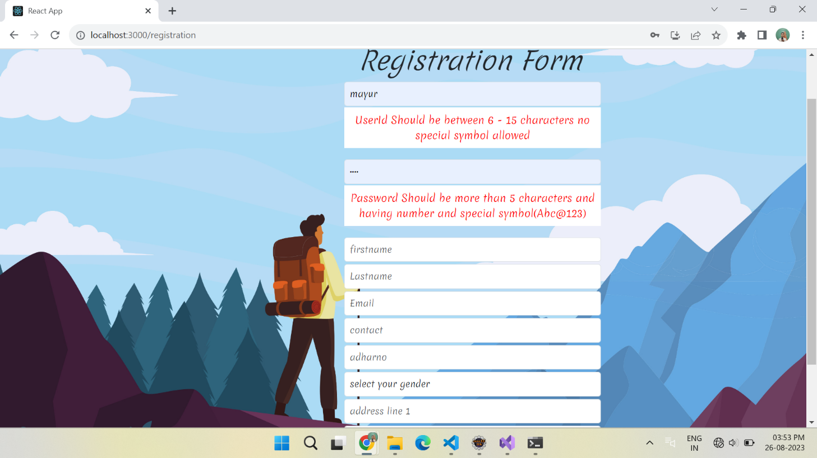

**8.4.3 Add Trek**

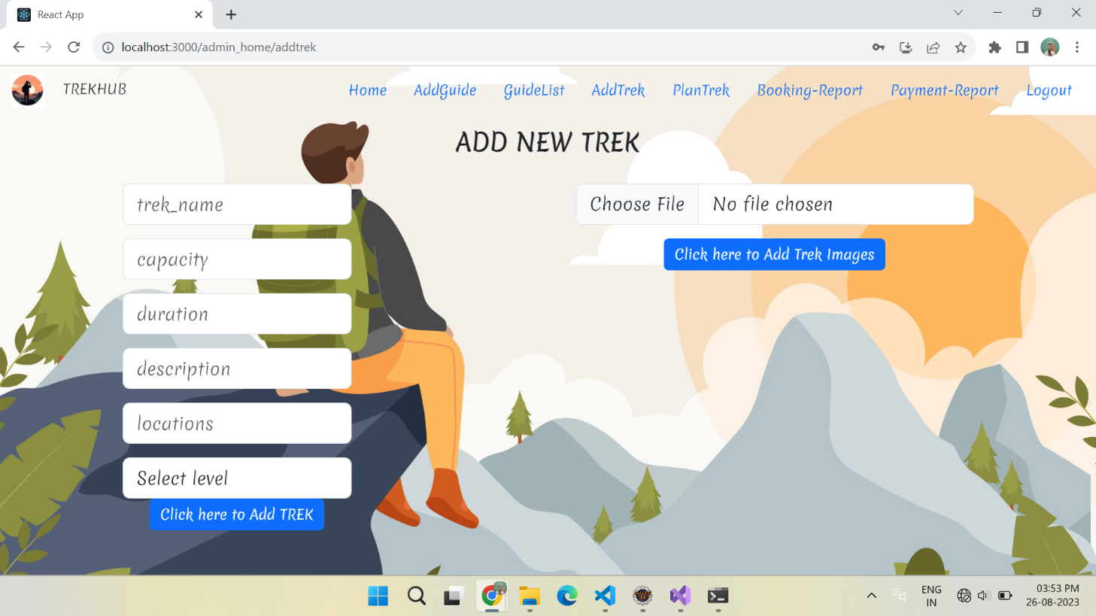

**8.4.4 Plan Trek**

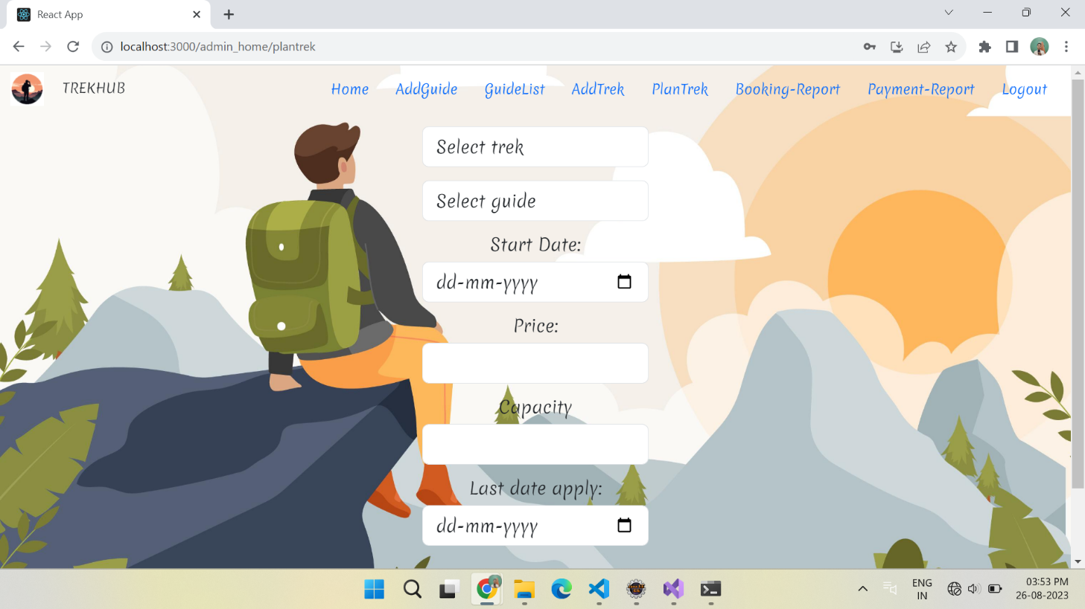

**8.4.5 Trek Bookings**

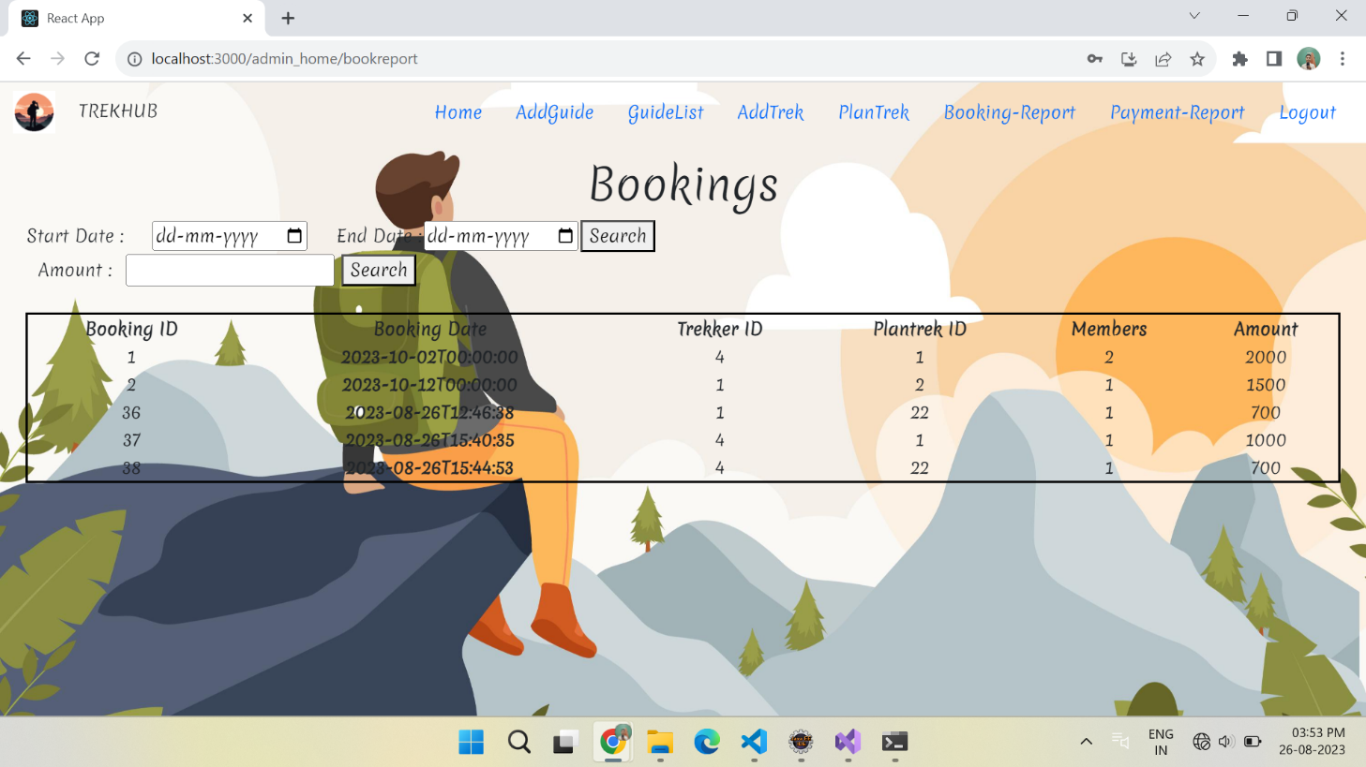

**8.4.6 Payments**

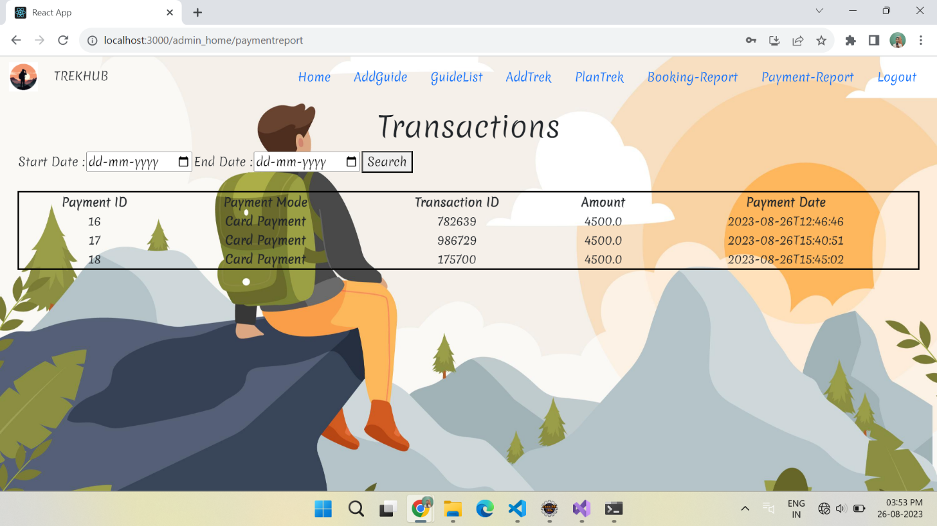

**8.5 Guide Home Page**

**8.5.1 Guide Profile**

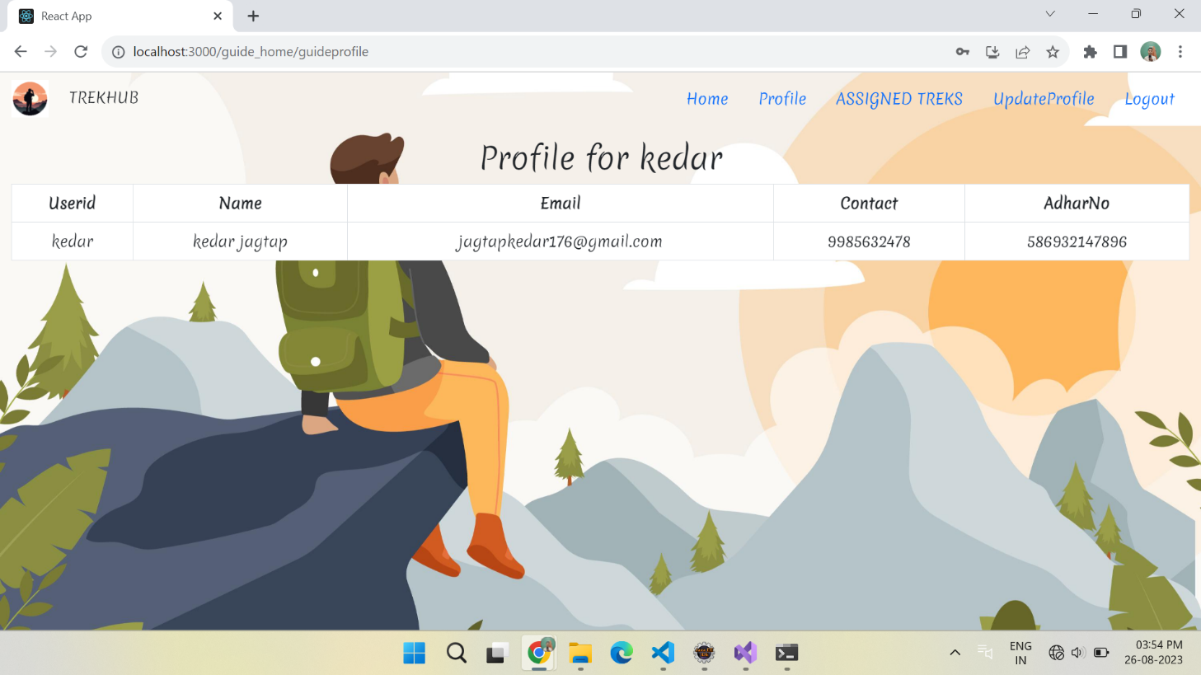

**8.5.2 Assigned Treks**

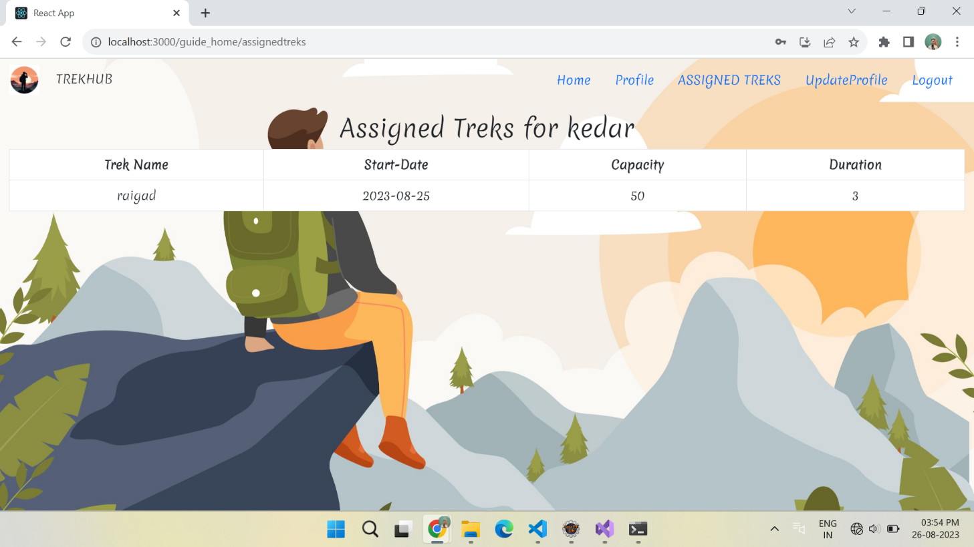

**8.5.3 Update Profile**

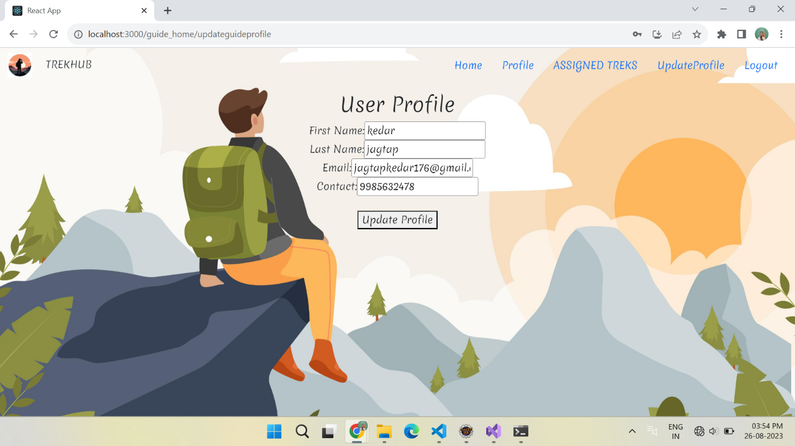

**8.6 Trekker Home Page**

**8.6.1 Trekker Home**

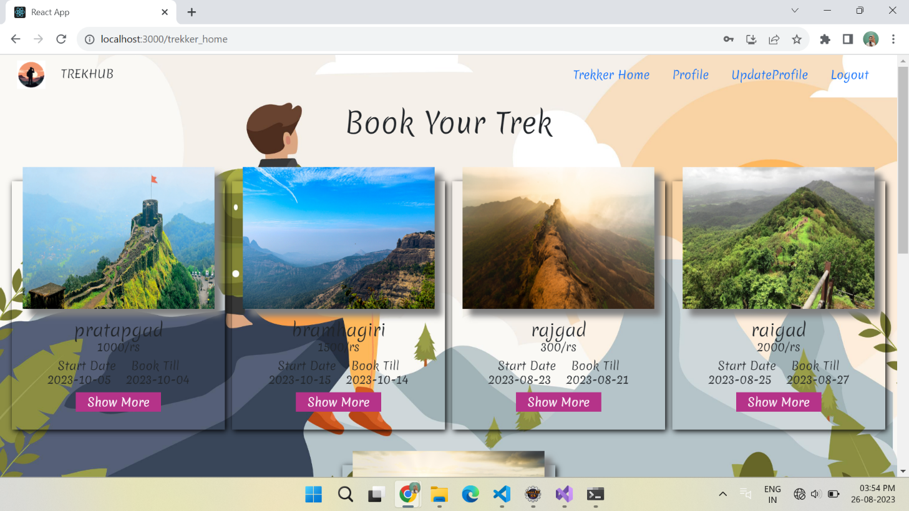

**8.6.2 Trek Description**

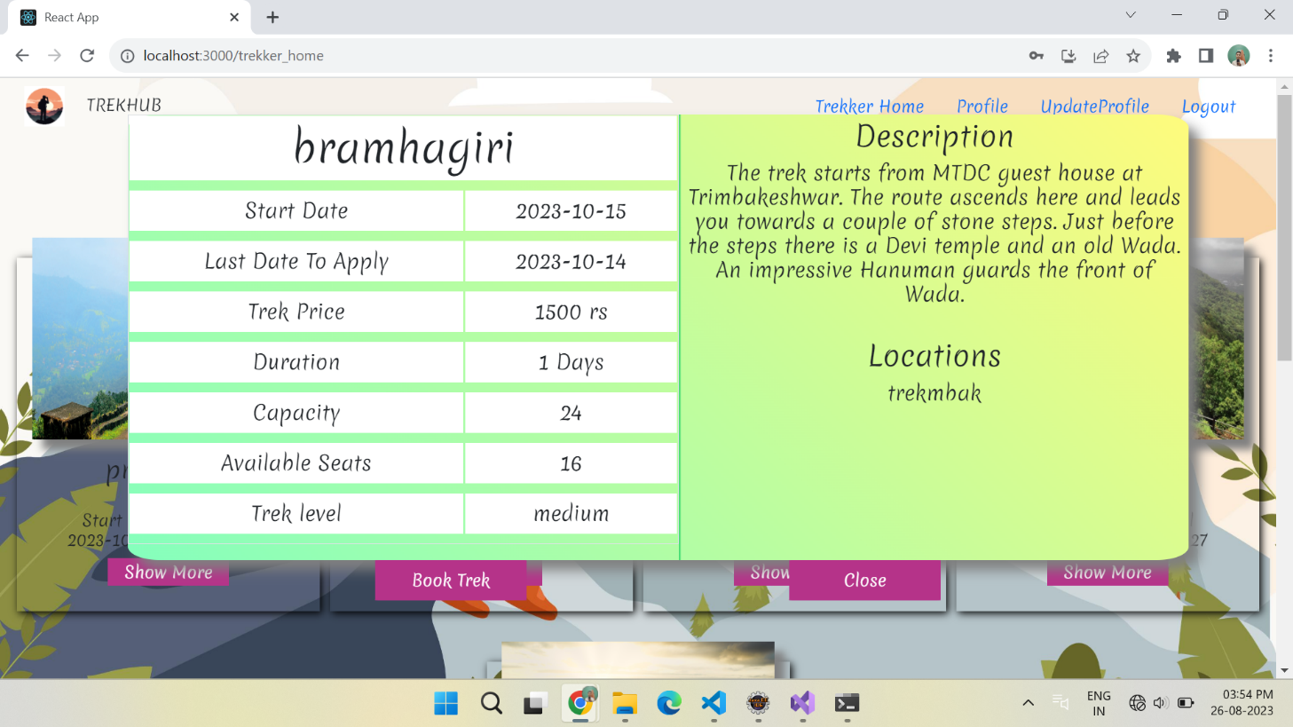

**8.6.3 Trek Booking**

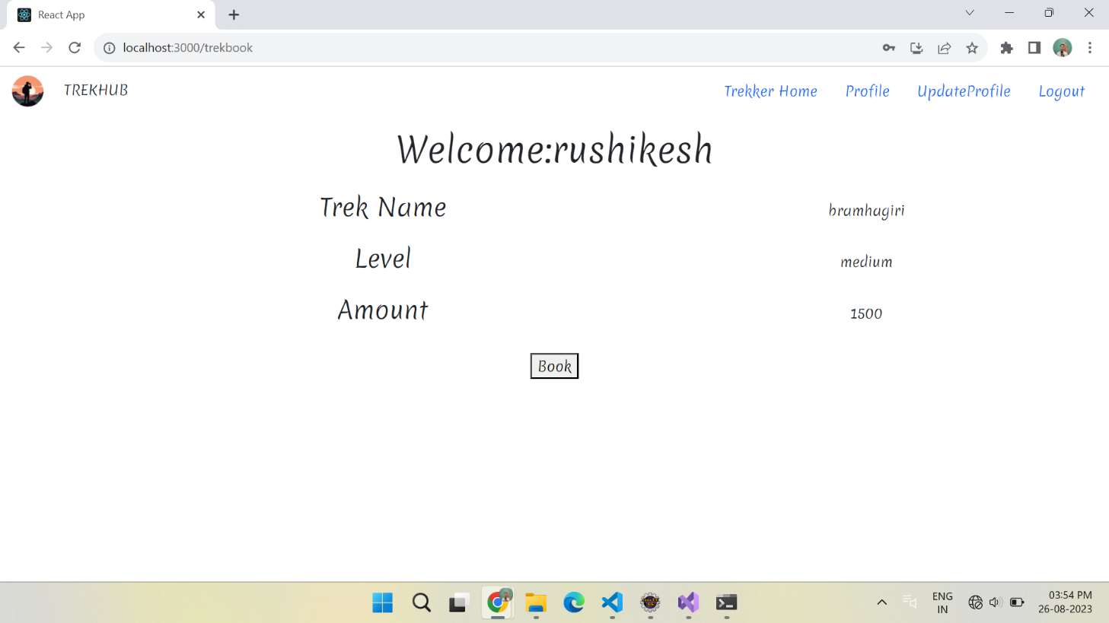

**8.6.4 Payment**

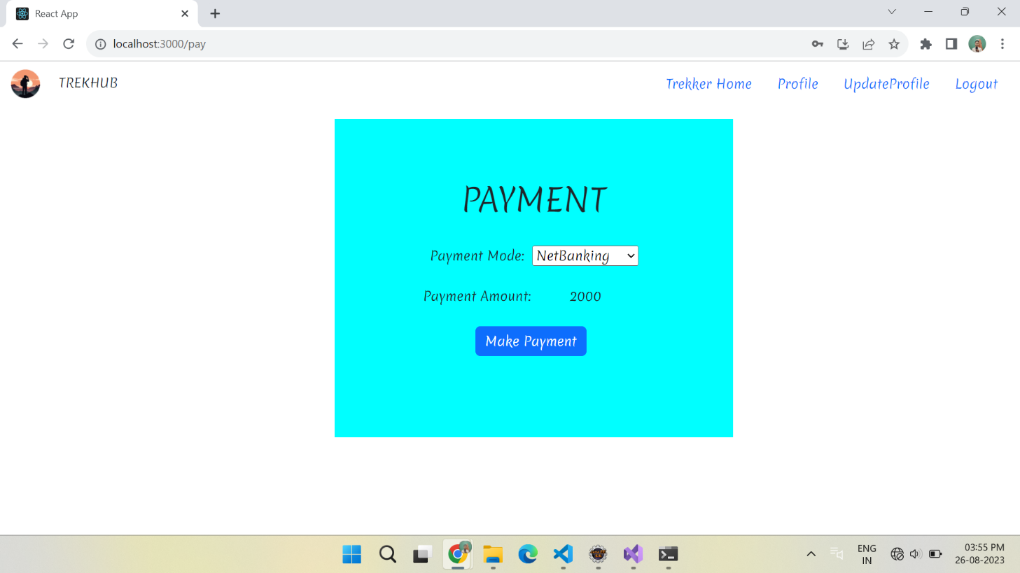

**9. CONCLUSION AND FUTURE SCOPE**

TrekHub provides better trek booking platform to book treks easily,economically and quickly.

Our System provides a very user-friendly platform where Trekkers can easily book treks with the help of images according to their date and location given by trekkers.

Our system will also provide functionalities like search by particular category, making travel arrangements, providing accommodation and trekkers will also be able to customize their packages according to their need.